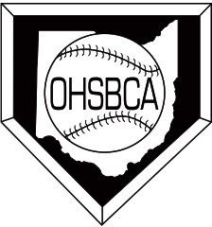
2021 Membership Form
Cost: $30.00
Mail to: Glen Morse
P.O. Box 275
New London, OH 44851
Make checks payable to: OHSBCA

Registration for the clinic includes your membership.
You must be a member of the OHSBCA to have nominating and voting privileges for Poll voting, the All-Ohio team and Senior All-Star Series. Membership also includes free admittance to OHSBCA sponsored games. If you are unable to attend the clinic, but wish to be a member, complete this form.
This form and $30 must be received no later than March 15, 2021.

Name: (Last) (First) (MI)

Home Address: Apt#:

City: State: Zip:

Phone#- Cell: School: Home:

EACH MEMBERS MUST HAVE A UNIQUE (one of a kind) EMAIL TO REGISTER

Email: (required)

School Name: School Address: City: State: Zip: Coaching Position: (Please circle one)
Head Coach Assistant Coach JH/MS Coach Rec/Youth Coach College Coach

District: (Please circle one)

Central East NE NW SE SW College Youth Retired

School Division: (Please circle one) League:

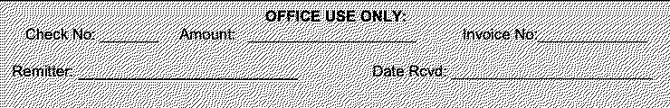
I II III IV
Receipt & Membership Card will be emailed

